Tesla Stock Price

Mirna Philip

University of San Diego

Master of Science, Applied Data Science

ADS-501 - Foundations of Data Science

Module One

January 16, 2023

| **Business Understanding** |
| --- |

**Background**

Tesla Stock Prices have been a hot topic this year. Before I say the reason for why Tesla stock has been a hot topic let me explain the background of Tesla. Tesla is an automotive company that was founded in 2003 by two engineers. The two engineers were Martin Eberhard and Marc Tarpenning, the name of the company was Tesla motors but it changed in 2017 to Tesla (Thompson, 2022). This organization is well known for its electric cars and energy storage using lithium-ion batteries and solar panels. What makes Tesla different from other companies is that Tesla takes more risks than any other companies.

Since tesla company has been doing well, Tesla Stock known as TSLA been a hot topic this year because there is a prediction that the stock of TSLA would reach 200 in the end of 2023. Even though the stock of TSLA been up and down throughout the two decades . TSLA stock started in 2011 when tesla introduced Model S where the stock price was 1.58$ but in 2020 the stock of TSLA increases from $31.88 to $235.22. In December 1, 2021, when tesla moves the headquarters to Texas the stock price was $365. During 2022, Tesla faced a racial discrimination lawsuit that caused the stock price to drop to $286 but Currently (January 16,2023) the stock price of TSLA is $122.40 (Contributor, 2022). The stock price of TSLA is low which is good news for the customers that want to buy shares of TSLA since the stock price is low right now and there is a high chance that the stock prices will go up soon. Therefore, the price of Tesla stock has risen over the years, and there is a good probability that it will rise once more.

| Problem area | Solution |
| --- | --- |
| Identify the problem area:Tesla's stock price can go up or down depending on how many cars they make and sell, how much competition they have, and what's happening in the global economy. | Solution: Tesla can improve production and delivery by better managing supplies, production, and logistics. To stay competitive, Tesla can innovate through research and development, expand market share, offer more services, and adapt pricing and advertising to changing global economic conditions. |
| Tesla stock prediction | The reason I want to do prediction model is to see if in the coming year the stock would increase or decrease. |

**Business objectives and success criteria**

The primary objective for Tesla Stock from a business perspective is to accelerate the global transition to sustainable energy through the design, development, production, and sale of electric vehicles, energy storage systems, and solar products (Musk, 2023). Overall, a successful stock will see consistent growth in these areas, have a positive outlook for future performance and be able to meet the business objectives of the company.

Tesla’s Success Criteria Include:

| Business Objective | Success Criteria |
| --- | --- |
| Revenue Growth | With increased manufacturing and sales of its electric vehicles, Tesla has seen a sharp increase in revenue the currently the revenue is $15.2 billion |
| Earning Per Share (EPS) | With a positive earnings per share of $1.68 for the quarter., Tesla has been continuously profitable in recent years. |
| Production and delivery of EV | it will be thoroughly analyzed to see if the corporation is able to reach its manufacturing and delivery goals for its electric vehicles. |
| Market Share | With a strong market share, Tesla dominates the electric vehicle industry. |

**Inventory of resources**

**Personnel Sources:**

The personal resources that are available for this project is a project manager that will be incharge of data mining , data scientist and a business expert. The name of the project manager is Mirna W. Philip.

**Data Source:**

I collected this data from user Aman Chuhan on Kaggle (2022). There was a single 63 kB CSV file with data from 2010 to 2022. Data file include:

* Seven columns
  + which are the date, open, high, low, and close and Adj Close and volume

**Software Source:**

For this project, the software that will be used is Python to do some data cleaning, predictive modeling and data visualization

**Hardware Source:**

The hardware that will be a personal laptop which is MacBook Air for this project.

**Requirements, assumptions, constraints, and RESOLVEDD Strategy**

**Requirements:**

| **Requirement** | **Acceptance Criteria** |
| --- | --- |
| **Identify target group profile** | Since Tesla stock is publicly traded and accessible to all, its target group profile is not limited to any specific demographic. |
| **Schedule of the project** | This project has a due date of February 20, 2023 and the goal is to complete it efficiently. Progress is being made and remains on track. |
| **Data mining project & Result model** | 1. Comprehensibility: The project is made easy to understand for both technical and non-technical people through the use of graphs and accompanying explanations. 2. Accuracy: The goal is to achieve accurate results with a high level of confidence. For this project the accuracy was 86%. 3. Deployability: This project can be quickly put into action in a real-world setting. 4. Maintainability: This project is maintainable over time since all and easy to update and improve as new tesla stock data becomes available. 5. Repeatability: The project gives the same results every time it is used, making it dependable. |
| **Legal and Privacy** | 1. Security: The information for this project is safeguarded by Mirna Philip and Erin Cooke. Mirna Philip is the sole person with full access control, ensuring that the data cannot be altered or edited by anyone. 2. Legal restrictions: legal requirements that must be followed:    1. Data protected by making sure that nothing in the data get change not edited by anyone    2. Ensuring the privacy and confidentiality of the information involved in this project. 3. Privacy: Protection of personal data and the management of sensitive information. 4. Reporting: All information has been documented and is ready for implementation. 5. Project Schedule:    1. This project started on January 10, 2023 and is expected to be completed by February 20, 2023. The presentation deadline is also set for February 20, 2023. |

**Assumptions**

| **Assumption** | **Acceptance Criteria** |
| --- | --- |
| **Data quality** | 1. Data accuracy: The accuracy for this project is 86% accuracy assumed that the data is correct and free from errors. 2. Data Availability: let's assume this project allows anyone to predict stock market prices by importing a new dataframe of their choice. |
| **External factors** | 1. Competitive products: Tesla is known for producing high-quality, sustainable products, which has helped establish a strong brand reputation and attract both consumers and investors. The company has also consistently shown strong financial performance, with growing revenues and profits, indicating stability and potential for growth to investors. So, let’s assume that Tesla launch new electric car with new features, then the stock market of Tesla will go up. 2. Technical advance: Assume that Tesla found new artificial intelligence that can increase efficiency, reduce costs, and improve the quality of products and services. |
| **Estimate the cost of the project** | Assuming the budget for this project is $25,000, with $10,000 allocated for the data scientist and $15,000 for project management. |
| **Model Understand** | The aim of this project is to forecast the trends in Tesla stock prices by analyzing historical data and visualizing patterns through graphical representations. The results of the project will be presented by Mirna Philip in a comprehensive presentation to the senior management, highlighting the background, objectives, and outcomes of the project. |

**Constraints**

| **Constraint** | **Acceptance Criteria** |
| --- | --- |
| **General Constraint** | Tesla faces legal constraints from regulatory bodies such as the SEC for financial reporting, safety, and IP. Its budget for R&D and capital expenditures, as well as production costs, could impact stock price. Ambition targets for vehicle production and delivery, vulnerable supply chains, and competition may affect stock price in the short and long term. Limited number of suppliers and competition for talent could impact Tesla's ability to innovate and execute its strategy, affecting stock price. |
| **Technical accessibility** | 1. Operating system is macOS 2. Data management system is Relational Database Management System (RDBMS) 3. File database was a CSV file. |
| **Budget** | For Tesla, this includes employee salaries, factory costs, and creating new vehicles and charging stations. |

**RESOLVEDD Strategy**

**1.Review the fact:**

Tesla, an automotive company well known for electric cars and energy storage, has been a hot topic due to predictions that its stock (TSLA) will reach $200 by the end of 2023 despite ups and downs in the stock price over the years. The current low stock price of $122.40 presents a good opportunity for customers to buy shares, as there is a high chance the stock prices will soon rise again.

**2.Estimate the problem:**

Tesla faces competition in the electric vehicle market which could lead to decreased profits and a negative effect on the company's finances and stock price. Additionally, being a publicly listed company, Tesla's stock price is influenced by market changes and investor sentiment, and the company has a history of financial losses and reliance on debt.

**3.Solution:**

The price of Tesla products should be balanced between affordability for consumers and profitability for the company. To be successful, Tesla should also invest in marketing and promotion to increase brand awareness, diversify its investments to minimize the impact of price fluctuations, and implement clear risk management policies.

**4.State important and probable outcomes:**

As previously mentioned, some solutions to mitigate competition and market risks include marketing and promotions, diversification, and risk management policies.

**5.Describe the likely impact of each main solution:**

* **Solution Marketing and Promotions:** Boosts visibility and reputation, attracts and retains customers, creates competitive advantage.
* **Solution Diversification:** Reduces dependence on one area, spreads risk for stability and resilience.
* **Solution Risk Management Policies:** Helps identify, assess, and manage potential risks for stability.

**6.Explain the values upheld and those violated by each main solution:**

| **Solution** | **Upheld** | **violated** |
| --- | --- | --- |
| **Solution Marketing and Promotions** | 1. Visibility 2. Reputation 3. Customer satisfaction and retention 4. Competitive advantage | None |
| **Solution Diversification** | 1. Stability 2. resilience 3. risk management | None |
| **Solution Risk Management Policies** | 1. stability 2. risk management | None |

**7.Evaluate each mean solution in term of outcome:**

| **Solution** | **Outcome** |
| --- | --- |
| **Solution Marketing and Promotions** | 1. Better brand image and customer loyalty 2. Higher sales and revenue 3. Competitive advantage |
| **Solution Diversification** | 1. Stability and resilience in the face of market changes 2. Mitigated impact of downturns or failures |
| **Solution Risk Management Policies** | 1. Improved risk management 2. Increased stability in handling and responding to risks |

**8.Decide which solution is the best:**

In my view, the most effective strategy for enhancing the value of Tesla's stock would be to focus on Solution Marketing and Promotions. This approach has the potential to not only improve the brand image and customer loyalty but also drive higher sales and revenue, which are key factors that contribute to the growth and stability of the company.

**9**. **Defend the decision against objection to its main weaknesses:**

An objection to focusing on Solution Marketing and Promotions for Tesla's stock is that it doesn't address fundamental challenges such as operational efficiency or financial stability. This decision can be defended by recognizing that marketing and promotions can still impact the overall value of the company by improving brand image, customer loyalty, sales, and creating a competitive advantage. These factors can also help provide resources for addressing other issues. However, to address market changes and disruptions, Solution Diversification and Solution Risk Management Policies should also be considered. A comprehensive and well-rounded strategy that addresses multiple business challenges is likely to have the greatest impact on the value of Tesla's stock.

**Risks and contingencies**

Tesla is known for taking risks and leading the electric vehicles industry. There are numerous risks and Contingencies that this organization may encounter. Some of the risks and Contingencies are market risk, competition risk, ETC (will be provided in the table below).

| Risks | Contingencies |
| --- | --- |
| **Competition risk:** It is not surprising that Tesla faces intense competition in the market for electric vehicles. This competition can result in price wars and lower profits. That would have a negative impact on the company's financial performance and stock price. | **Pricing** : the price for the Tesla should not be too high where the consumers can offer it and not too low where the company can’t make profit.  **Marketing and Promotions:** It’s always good to promote the business. So more people know about the company. |
| **Market risk:** Due to the fact that it is a publicly listed business, Tesla's stock price is subject to changes based on changes in the overall market and investor sentiment. | **Diversification:** Investing across a diverse range of investments and industries,Price fluctuations have the least amount of influence on any given investment. |
| **Financial risk:** The business has a track record of losing money, and it has been claimed that Tesla has been highly reliant on debt to support its operations. | **Risk management policies:** Clearly define the rules for risk management, such as limiting the amount of money that can be invested in a single stock or industry. |

**Terminology**

| **Business Glossary** | **Definition** |
| --- | --- |
| Buy in stock market | to buy a share in a company |
| Sell in stock market | to sell a share from the company |
| Day Trading | is practice of buying and selling within the same trading day |
| Market Capitalization | The total value of a publicly traded company based on its stock price and number of outstanding shares. |
| Earnings per share (EPS) | A company's profit divided by its outstanding shares, indicating how much profit each share represents. |
| Going long | is when you bet on a company’s stock that will increase in price where you can buy it the stock price low and sell it high. |

| **Data Science Glossary** | **Definition** |
| --- | --- |
| Python | a programming language that performs exploratory data analysis, data cleaning, and data visualization and other statistics if needed. |
| Exploratory Data Analysis (EDA) | a tool to help you evaluate the data and using trials and errors to discover and analyze relationships in the data. |
| Data cleaning | is a process of importing the data, removing duplicate data,and filling in missing data, and etc. |
| Predictive Modeling | is a method for determining results from data by analyzing its patterns. |
| Data Visualization | is a method that collects several pieces of information from data using visual graphs (bar chart, box plot, and scatter graph). |

**Data mining goals and success criteria**

The primary goal of this project is to do data analysis and predictive modeling in order to predict the price of Tesla stock. This will involve evaluating past stock performance data as well as a number of variables that could affect the stock price, including company performance, market trends, macroeconomic conditions, and any other pertinent variables. In addition to Predictive Modeling, performing other data mining techniques in this project.

One of these techniques is Market Sentiment Analysis. This will involve analyzing social media and news sources to identify public sentiment towards the company and its stock. Another data mining technique is Risk Management. It identifies potential risks that could negatively impact the company's stock prices, such as changes in regulations, competition, or economic conditions.

In summary, The primary goal in this project is to analyze the data and perform Predictive Modeling to predict the price of Tesla stock, but there will be other data mining techniques such as Market Sentiment Analysis and Risk Management to gain a more comprehensive understanding of the stock and its potential future performance.

| **Data Mining Goals** | **Success Criteria** |
| --- | --- |
| **Predictive Modeling:** One of the main goals of this project and the data mining is to predict the price of Tesla stock using the historical data and market trends. | Predictive modeling must be highly accurate and effective in identifying important factors that influence stock prices. |
| **Market sentiment Analysis:** Analyzing social media and news sources to evaluate public perception of the company and its shares is another important aspect of data mining for Tesla stock. | The ability to recognize sentiment patterns over time and to spot any major changes in sentiment that might have an impact on stock prices would be success criteria for market sentiment analysis. |
| **Risk Management:** Finding possible threats to the company's stock values, such as changes in the law, competition, or economic situations, | Success criteria for Risk Management would include accurate identification and quantification of possible risks, as well as the ability to develop plans to reduce or manage such risks, would be success criteria for risk management. |

**Project plan/ Order of tasks (Insert Gantt Chart here for Module 6 submission.)**

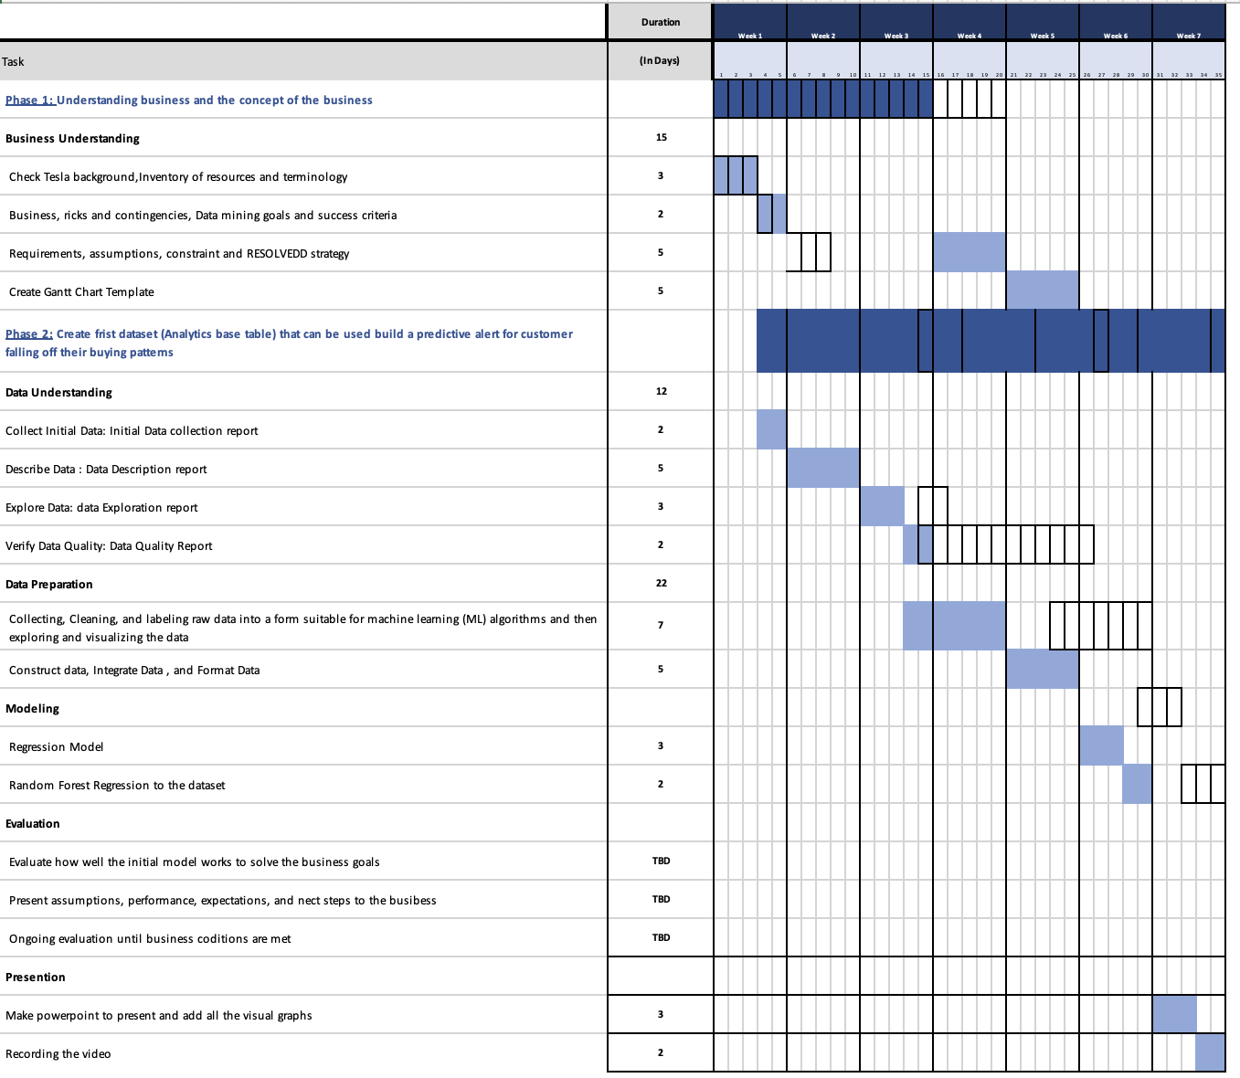

| **Data Understanding** |
| --- |

**Initial data collection report**

This dataset consists of one csv file that has seven columns and 3077 rows and it was collected from kaggle from a user called Aman Chuhan. Also this data set was collective from 2010 to 2022 and I'm planning to use all attributes for my forecasting . The goal of this data is to predict the price of TSLA stock if it will increase or decrease for the coming months or year.

| **Field** | **Description** |
| --- | --- |
| Date | Date (YYYY-MM-DD) |
| Open | The stock's opening price |
| High | The high price of that day |
| Low | The low price of that day |
| Close | Price when the market closes |
| Adj Close | closing price adjusted in base of company activities |
| Volume | Amount of stocks sold in a day |

**Data description report**

As previously mentioned, the data for this analysis was obtained from a user named Aman Chuhan on the popular data science platform, Kaggle. The dataset was provided in a single CSV file, named "TeslaInc. (TSLA).csv". This file contained a total of 3077 rows and 7 columns, which were date, open, high, low, close, adj. close, and volume. These columns provided various financial information on the performance of Tesla stock.

It is important to note that this dataset did not contain any missing or null data, which can be a common issue when working with real-world datasets. This made the data ready to use without the need for any further cleaning or pre-processing. The data types of each column were also provided in table 1 and figure 1, which contain the count, mean, std and other information of the data. Overall, this dataset provided a comprehensive and precise representation of the stock's business performance throughout time.

Table 1:

| **Field** | **Dtypes** |
| --- | --- |
| Date | Object |
| Open | Float64 |
| High | Float64 |
| Low | Float64 |
| Close | Float64 |
| Adj Close | Float64 |
| Volume | Int64 |

Figure 1:

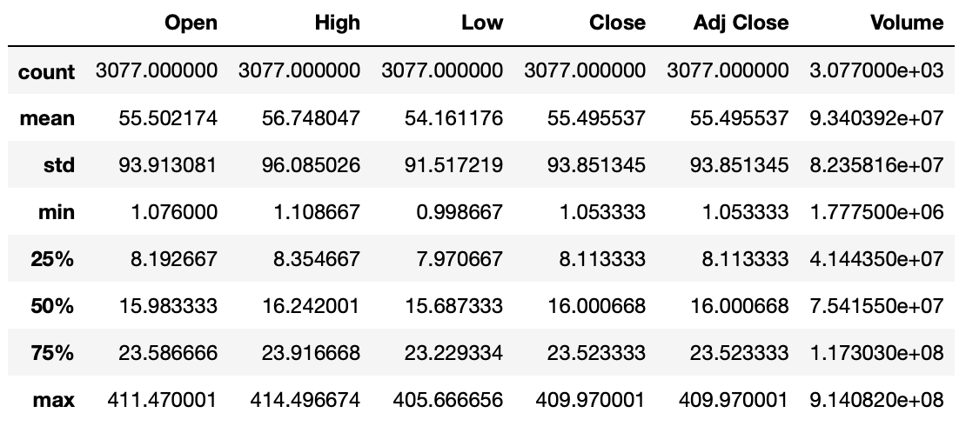

**Data exploration report**

After reviewing the data and statistics of Tesla stock, a pattern was observed. The pattern suggests that as the Tesla stock market increases, the number of stock investors will also increase. The alternative hypothesis of this study is that a higher closing price will result in more stock investors in Tesla. Analysis of figure 2 showed that in 2020, Tesla stock prices started to rise and more shares were sold. However, the stock prices declined at the end of 2021. Although this supports the hypothesis that increased stock prices result in more shares being sold, there is no explanation for the decline in stock prices in late 2021. Figure 4 demonstrated that there was minimal difference between the close, high, and low prices of Tesla stock. This observation suggests that there is little variation between the close, high, and low prices of Tesla stock.

The results of this study provide evidence supporting the hypothesis that an increase in Tesla stock prices results in an increase in the number of stock investors. However, the decline in stock prices at the end of 2021 remains unclear. Additionally, the observation of minimal differences between the close, high, and low prices of Tesla stock highlights the stability of the stock. Further research may be necessary to fully understand the factors impacting the stock market and prices of Tesla stock.

**Figure 2:**

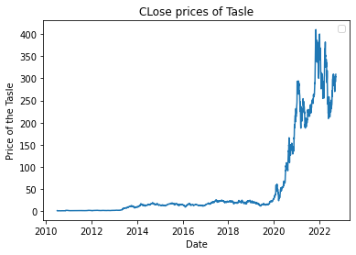

**Figure 3:**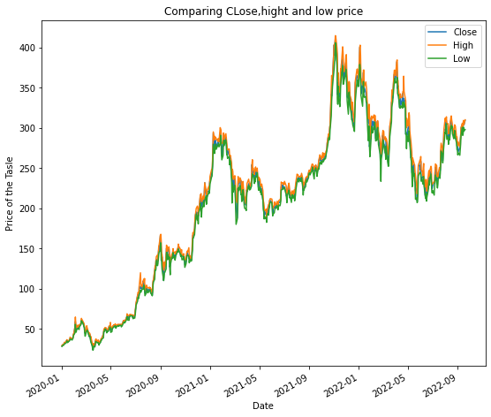

**Data quality report**

After reviewing the data of the Tesla stock, I found no missing or duplicate data points. The only action taken to enhance the data quality was rounding the decimal places to two decimal places.

Checklist to have quality data:

| **Convert raw data to data quality** | **what it needs to be done** |
| --- | --- |
| Data Cleaning | This data did not have any missing data nor any duplicate |
| Data Validation | Round the decimal places for close, high and low columns to the hundredths place decimal. |
| Data Transformation | After rounding the decimal places of the data, it has become easier to understand and analyze. |
| Data Standardization | The data was already in the correct currency format and required no standardization. |
| Data Integration | No additional data sources were necessary for data integration, as the current dataset had all necessary information. |
| Data Enrichment | No data enrichment was needed as the dataset already contained all relevant information. |

References

Cadie Thompson, K. L. (n.d.). *Tesla just celebrated its 12th year as a public company. Here are the most important moments in its history.* Business Insider. Retrieved February 20,2023, from https://www.businessinsider.com/most-important-moments-tesla-history-2017-2#july-2003-tesla-motors-is-founded-by-a-group-of-silicon-valley-engineers-1

Contributor, B. G. (2022, October 18). *Tesla History Timeline: Evolution & Stock prices*. CleanTechnica. Retrieved February 20, 2023, from https://cleantechnica.com/2022/10/18/tesla-history-timeline-evolution-stock-prices/

Tesla. (n.d.). Elon Musk. Retrieved from<https://www.tesla.com/elon-musk>.